Student name: Naazim Changani

Student ID: 8762353

Course: Entrepreneurship

Course code: ENTR8080-22W-Sec1

Professor:  Mr. Phillip J Brand

Assignment 1: Multi-level Business Environment Analysis of Hayai Desire

MULTI-LEVEL BUSINESS ENVIRONMENT ANALYSIS

Analysis of Hayai Desire

Table of Contents

PESTEL Analysis 2

Political Factors 3

Economic Factor 4

Social Factor 5

Technological Factor 6

Environment Factors 7

Legal Factors 8

Porter’s Five Forces 9

Marketing Strategy Analysis 12

Objective of Marketing Strategy 13

Five Stages of Marketing Strategy Process 13

Step 1 – Marketing Research and Analysis 14

Step 2 – Selecting Target Customer Segment 15

Step 3 – Making a Marketing Plan 17

Step 4 – Four Ps of Marketing 17

Step 5 – Post Purchase Services 18

SWOT Analysis 19

Strengths – Hayai Desire 19

Weaknesses – Hayai Desire 20

Opportunities – Hayai Desire 22

Threats – Hayai Desire 24

Core Competencies 26

Bibliography 27

# PESTEL Analysis

PESTEL analysis is a strategic framework used to evaluate the external environment of a business by breaking down the opportunities and risks into Political, Economic, Social, Technology, Environment, and Legal factors.

PESTEL analysis can be an effective framework to use in corporate strategy planning and for identifying the pros and cons of a business strategy. The PESTEL framework is an extension of the PEST strategic framework, one that includes additional assessment of the environment and legal factors that can impact a business.

**Importance of PESTEL Analysis in strategy management & planning process**

1. Choosing the vision, mission and the reason of existence for Hayai Desire.
2. Analyse the Hayai Desire external competitive environment to identify opportunities and threats.
3. Analyse Strengths and Weakness of Hayai Desire.
4. Developing strategies that can capitalize on Hayai Desire strengths and help mitigate weakness and impact of threats of macro-environment.
5. Execution of the strategy and building a feedback loop, using which Hayai Desire can fine tune processes and strategies going forward.

## Political Factors

The political factors environment and other factors not only impact the cost of doing business but also long-term sustainability. Some of the political factors are – governance system, democracy and institutions, military coup chances, probability of armed conflict, law and order in market etc.

**Political Factors Impact**

**Transitions of Government and changes in policy** – There is consistency in policy making from one government to another. Secondly government from all parties adhere to the treaties made by the previous government.

**International Trade & Other treaties** – The country has a good record of adhering to international treaties it has done with various global partners. The government of each party has adhered to the treaties done by pervious governments, so there is a consistency in both rule of law and regulations.

Role of Non-Government Organization, Civil society & Protest Groups – The country has a vibrant civil society community and Hayai Desire should build bridges with them and seek out areas of co-operations. Civil society groups are influential not only in policy making but also in building a society wide narrative.

**Threat of Terrorist Attacks** – I believe in the world of post 9/11, Hayai Desire have to live with operating under the shadow of a terrorist attack. The prudent policy should be to take insurance and other types of hedging instruments to mitigate the losses occurring because of the terrorist attacks.

**Judiciary Independence** – In the matter of commercial and business decision, judiciary of the country is independent to a large extent. Business do face problem when conflict is between public interest and proprietary technology similar to ruling in South Africa where government & judiciary allowed generic AIDs drug irrespective of patents of global companies.

**Segregation of Political Responsibilities between Different Government Agencies** – There are numerous government agencies which reduces the risk of overwhelming pressure by one agency. But on the flip side it does increases both time and cost of doing business and getting certifications and clearances.

**Regulatory Practices** – The regulatory practices are streamlined with global norms which have helped the country to improve its “ease of doing business” ranking.

## Economic Factor

Economic factors of a country and region have a direct impact on the potential attractiveness of a given market. Some of the economic factors that Hayai Desire should evaluate both in the resent market and one in which it wants to enter are – inflation rate, GDP growth rate, disposable income level etc.

**Economic Factors Impact**

**Employment rate** – If the employment rate is high then it will impact Hayai Desire strategies in two ways – it will provide enough customers for Hayai Desire products, and secondly it will make it expensive for Hayai Desire to hire talented & skilled employees.

**Level of Household income and saving rate** – Increasing consumption and stagnant household income in United states had led to credit binge consumptions. It has decimated the culture of saving as people don’t have enough to save. Hayai Desire needs to be careful about building marketing strategy that is dependent on “Purchase on Credit” consumer behaviour.

**Government Spending** – Government of the country is running deficit budgets. The implication for Hayai Desire is that it can boost sales of its product in short run but also expose Hayai Desire to medium term forex and currency depreciation risks.

**Price Fluctuations In both Local and international markets** – Compare to the level of quantitative easing in last decade the prices of Hayai Desire product and prices of overall product have remained sticky in the US market. Hayai Desire should consider the fact that at deficit levels of United States in an emerging economy can lead to rampant inflations and serious risks of currency depreciation.

**Work Force Productivity** – Work force productivity in US has growth by 25-30% in the last decade even through the salaries are not reflecting those gains. It can enable Hayai Desire to hire skilled workforce at competitive salaries.

**Foreign Exchange Rate** – Number of companies have incurred losses in past few years because of forex risk. Hayai Desire should be careful about the history of forex risk before entering new market.

## Social Factor

Social factor such as demography trends, power structure in the society, women participation in workforce etc have immense impact over not only the country’s economy but also on workforce talent availability and level of consumer demand.

**Social Factors Impact**

**Demographic Trend** – The demographic trend is one of the key factors in demand forecasting of an economy. For example, as the population of USA and EU is growing the demand for products mostly catering to segment will grow. Hayai Desire should consider demographic trends before new product development and integrate features that cater to this segment.

**Societal Norms and Hierarchy** – What sort of hierarchy and norms are acceptable in society also influence the types and level of consumption in a society. In highly hierarchical societies the power of decision making often reside at the top.

**Attitude towards savings** – The culture of saving in US and China is totally different where saving rate in China is around 30%, it is well below 15% in US. This culture of consumption and savings impact both type of consumption and magnitude of consumption.

**Education Level in Society** – Education level in society impacts both the quality of jobs and level of income. High level of education often results in better jobs, higher income and higher spending complex and aspirational products.

**Power structure in Society** – Hayai Desire should be carefully analysed both – what is the power structure in the society? how it impacts the demand in the economy. For example, power structure in the US economy is slowly moving towards disposable income compare to the younger generation.

**Attitude towards Leisure** – Hayai Desire should conduct ethnographic research to understand both attitude towards leisure activities and choice of leisure activities. Experience economy is one of the fastest growing segments both among millennials and among baby-boomers.

**Attitude towards Health & Safety** – Health and safety often reflected in the quality of the products and cost structure of manufacturing processes. Hayai Desire should have stringent norms for health and safety norms so in emerging economies it may have to complete with players who don’t have high-cost structure that of Hayai Desire.

## Technological Factor

Technology is fast disrupting business models across various industries. Some of the technology trends that are impacting the Marco-environment are developments in artificial intelligence, use machine learning and big data analytics to predict consumer behaver, growing importance of platform over service providers etc.

**Technological Factors impact**

**Mobile phone & internet Penetration** – Hayai Desire should assess the level of internet and mobile phone penetration in the country as it will build a requisite business model based on local needs and realities.

**Level of Acceptance of technology in the society** – Hayai Desire has to figure out the level of technology acceptance in the society before launching new products. Often companies enter the arena without requisite infrastructure to support the technology-oriented model.

**E-commerce & Related infrastructure Development** – As E-commerce is critical for Hayai Desire business model. It should evaluate the e-commerce infrastructure, technology infrastructure before entering a new market.

**Research and Development investment Levels** – If there is high level of investment I technology development sector then there are high chances of building a self-sustaining ecosystem that drives innovation. Hayai Desire can leverage such a situation to hire the best people in business.

**Integration of Technology into society & Business Processes** – Uber failed in China because it tried to enter before smartphones were widespread in China. Hayai Desire should build a strategy that can integrate societal values, infrastructure, and Hayai Desire business model.

**Transparency & Digital Drive** – Hayai Desire can use digitalization of various processes to overcome corruption in the local economy.

**Intellectual Property Rights and Patent Protection** – Before entering new market Hayai Desire should focus on the environment for intellectual property rights.

**Technology transfer and licensing issues for Hayai Desire** – Laws and culture of licensing of IPR and other digital assets should be analysed carefully so that Hayai Desire can avoid shakedowns and IPR thefts.

## Environment Factors

Environment factors are fast gaining reaction not only among consumers but also among regulations and policy makers. Climate change and changing ecosystem I leading to the extinction of more than 20% of species on the planet by the turn of this century.

**Environment Factor Impact**

**Corporate social responsibilities culture** – Are Hayai Desire present CSR efforts applicable in the new market or does it need to have new initiative to cater to the prospective market.

**Paris Climate Agreement and commitment of National Government under the agreement** – What are the commitments of the country under the Paris Agreement and what Is the general level of consensus regarding Paris climate agreement in the country.

**Per capita and National carbon Emission** – What is the per capita carbon emission of the country and what is the overall level of carbon emission of the country> this will help in better predicting the environment policy of the country.

**Level of consumer Activism Regrading Environment Concerns** – Hayai Desire needs to known the level of consumer activism regarding environment concerns is. It will help Hayai Desire in both developing environmentally friendly products and thwarting PR stumble blocks.

**Environment Regulation** impacting Absolute cost advantage dynamics in the industry.

**Recycle Policies** – What are the recycle policies in prospective market and how Hayai Desire can adhere to those policies.

**Influence of climate change** – How climate change will impact Hayai Desire business model and supply chain. For example, if the supply chain is not flexible it can lead to bottlenecks if shipments form one part of the world are delayed because of sudden climate shift.

## Legal Factors

Legal factors often govern-conditions to enter the market, laws to operate in the market and procedure to resolve any dispute with other stakeholders. If the legal system is not strong then Hayai Desire can face numerous challenges-from consumer petitions to shakedown form authorities.

**Legal Factors Impact**

**Securities Law** – What are the securities law in the country and what are the conditions to list the company on national or regional stock exchange.

**Data Protection Laws** – Hayai Desire needs to assess what are the data laws in the country and what it needs to do to comply with them.

**Health & Safety Laws** – What are the health and safety laws in the country and what Hayai Desire needs to do to comply with them. Different countries have different attitude towards health and safety so it is better for Hayai Desire to conduct a thorough research before entering the market.

**Transparency in Judiciary system & processes** – Transparency is essential for fair and consistent decision making. IF the process is consistent and transparent then Hayai Desire can plan ahead with greater conviction.

**Consumer Protection Laws** – Hayai Desire needs to know what are the consumers laws, what is the rate of enforcement, what is the attitude of authorities towards consumer protection laws, and what is the role activist groups in enforcement of consumer protection laws.

**Business Laws** – Before entering into new market Hayai Desire has to assess what are the business laws and how they are different from other markets.

**Intellectual Property rights protection** – Hayai Desire should assess the level of protection that intellectual property rights get under the legal system of the country.

**Key Takeaways**

For competitive advantages, companies must carry out PESTEL analysis on an interval of 6 months to measure the effectiveness of their strategies in the changing environment. Through PESTEL, the company can identify its threats and determine the opportunities assessing all the macro-environmental factors. **Hayai Desire PESTEL analysis** points out the keys issues that might pose a problem in it also help on producing strategies that will help achieve its long-term goals. At the same time, it highlights the factors such as technological and social that will help the top player to hold its place in the online retail market.

# Porter’s Five Forces

Porter’s five forces is a business analysis model that help to explain why various industries are able sustain different levels of profitability. The model was published in Michael E. Porter’s book, “Competitive Strategy: Techniques for Analysing Industries and Competitors” in 1980. The five forces model is widely used to analysing the industry structure of a company as well as its corporates strategy. Porter identified five undeniable forces that play a part in shaping every market and industry in the world, with some caveats. The five forces are frequently used to measure competition intensity, attractiveness and profitability of an industry or market.

## Porter Five Forces that Determine Industry Structure

1. **Bargaining power of suppliers of Hayai Desire** – If suppliers have strong bargaining power, then they will extract higher price form Hayai Desire.
2. **Threat of substitute products and services** – If the threats of substitute are high then Hayai Desire has either continuously invested into R&D or it risks losing out to disruptors in the industry.
3. **Bargaining power of buyers of Hayai Desire** – If the buyers have strong bargaining power, then they usually tend to drive price down thus limiting the potential of the Hayai Desire to earn sustainable profits.
4. **Threat of new entrants** – If there are strong threats of new entrants then current players will be willing to earn less profit to reduce the threats.
5. **Rivalry among existing players** – If competition is intense then it becomes difficult for exiting players such as “Instacart Grocery”, “Amazon”, “DoorDash” to earn sustainable profit

**Porter’s 5 Force Competitive Force & Industry Analysis**

The core objective of strategists and leaders in an organization is to help the organization to build a sustainable competitive advantage and thwart competitive challenges.

Step 1 – Defining relevant industry for Hayai Desire.

Step 2 – Identify the competitors and group them based on the segments within the industry.

Step 3 – Assess the Porter Five Forces in relation to the industry and assess which forces are strong and which forces are weak.

Step 4 – Determine overall industry structure and test analysis of consistency.

Step 5 – Analyse recent and future changes in each force.

Step 6 – Identify aspects of industry structure based on the Porter 5 forces that might be influence by competitors and new entrants.

**Porter’s five forces framework used in development strategies**

To achieve average profits, compare to other industry players in the long run, Hayai Desire needs to develop a sustainable competitive advantage. Industry analysis using porter five forces can help Hayai Desire to map the various forces and identify spaces where Hayai Desire can position itself. By doing industry analysis using Porter five forces, Hayai Desire can develop four generic competitive strategies.

**Four generic competitive strategies**

**Cost Leadership**

In cost leadership, Hayai Desire can set out to become the low-cost producer in its industry. How it can become cost leader varies based on the industry forces and structure. In pursuing cost leadership strategy, Hayai Desire can pursuit economies of scale, proprietary technology, supply chain management options, diversification of suppliers, preferential access to raw materials. And other factors.

**Differentiation**

Hayai Desire can also pursue differentiation strategy based on the industry forces. In a differentiation strategy Hayai Desire can seek to be unique in its industry by providing a value proposition that is cherished by buyers. Hayai Desire can select one or more attributes that can uniquely position it in the eyes of the customers for a specific need. The goal is to seek premium price because of differentiation and uniqueness of the offering. Industry analysis using porter five forces can help Hayai Desire to avoid spaces that are already over populated by the competitors.

**Focus – Cost Focus & Differentiation Focus**

The generic strategy of Focus rests on the choice of competitive scope within an industry. Hayai Desire can select a segment or group of segment and tailor its strategy to only serve it. Most organization follows one variant of focus strategy in real world.

**The Focus Strategy has two variants**

1. In cost focus Hayai Desire can seek a cost advantage in its choses segment in any category.
2. In Differentiation strategy Hayai Desire can differentiation itself in a target segment In its industry.

Both variants of the focus strategy rest on differences between Hayai Desire’s target segment and other segments in the industry.

**Porter’s Five Forces analysis important**

Hayai Desire can use porter’s five force model to analysis the competitiveness. Porter’s five force analysis of Hayai Desire help understanding and providing solution to nature & level of competition, and how Hayai Desire can cope with competition.

Even though from the outside various industries seen extremely different but analysed closely these five forces determine the drivers of profitability in each industry. Hayai Desire can use the porter’s five force to understand key drivers of profitability.

# Marketing Strategy Analysis

For successful marketing strategy at Hayai Desire, the marketing team needs to understanding of customers fundamental needs and drivers of those needs, conceptualizing products and services that can meet those needs and are feasible in Hayai Desire financial and intellectual resources, and finally developing marketing mix for entire go-to market strategy.

## Objective of Marketing Strategy

**Introduce a new product or service of Hayai Desire** – it is the traditional function of marketing mix launching a new product and communicating its features, superior value proposition, and uniqueness.

**Increase market share of Hayai Desire** – Marketing efforts can be used to increase market share either by driving increase in sales to new customers or by driving higher sales to existing customers.

**Increase sales of Hayai Desire** – The goals of marketing effort are to increase sales of the present products. It may involve selecting a new target segment or positioning an existing product differently to a new segment.

**Improve customer loyalty of Hayai Desire customers** – Marketing efforts can be used to increase loyalty among existing customers by organizing events and by providing post purchase information and services.

**Bring new customers to Hayai Desire** – It may involve launching version of product that can appeal to new segment of customers or entering into new markets.

**Get existing customers of Hayai Desire to buy more** – It often involves selling accessories along with the existing product or increase the usage rate of the existing products. Increase usage rate is comparatively a difficult task even with a war chest of huge marketing resources.

**Better establish the brands of Hayai Desire** – Brand awareness and positioning is one of the critical objectives of marketing and often organization spend a significant part of marketing budget on brand positioning.

## Five Stages of Marketing Strategy Process

Over the last decade the traditional role of marketing has diminished with the rise of artificial intelligence driven algorithms that provides marketers an easy to measure tool based on impression, clicks, and other behavioural aspects. But one thing that has been lost in this easy to measure culture is – The power of marketing functions to create new markets and customer segments.

**The five stages of Marketing Strategy Process of Hayai Desire are:**

Step 1 – Marketing Research & Analysis

Step 2 – Segmentation, Targeting & Positioning Decisions

Step 3 – Marketing Plan

Step 4 – Designing a Marketing mix using 4Ps

Step 5 – Sustaining Value through Post Purchase services

## Step 1 – Marketing Research and Analysis

The first stage of the marketing process at Hayai Desire is to do research and analysis to identify unmet and even unknown customer needs. A good point to start for the research and development is to conduct a 5C Marketing Analysis. The 5C Marketing Analysis framework: -

**Customer Needs** – What are the needs that Hayai Desire seeks to satisfy. Who are the present customers and who are the potential customers for the new product or services?

**Company** – What are the resources and special skills that Hayai Desire needs to possess to create products that can fulfil the needs of the prospective customers.

**Competitors** – Who are the competitors in the target market and what value proposition they are offering in the market place. Do they possess enough financial and knowledge resources to develop new products to compete with Hayai Desire?

**Collaborators** – What sort of supply chain and value chain partners Hayai Desire needs to develop and deliver new product to final consumer. What are the respective bargaining powers of value chain partners?

**Context** – What are the Marco and Micro environment factors that impact the business environment in which Hayai Desire operates in.

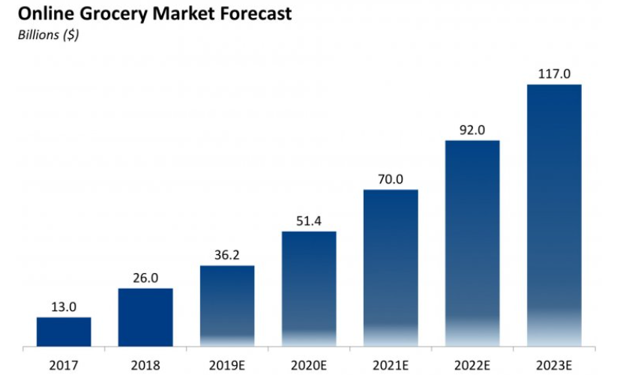

*Source: Business Insider Intelligence estimates*

## Step 2 – Selecting Target Customer Segment

**Segmentation**

Market segmentation is the process through which marketing at Hayai Desire can divide the large market into smaller segments based on distinct needs, characteristics, or consumer behaviour, Hayai Desire can do segmentation based on following criteria – geographic, demographic, usage, user status, income, lifestyle, value proposition priorities, benefits sought, loyalty status, gender, social class, self-perception, psychographic factors and other attitudes.

One of the most widely used multivariate segmentation system is PRIZM, developed by Clarita’s, it is widely used by various marketing and advertising agencies.

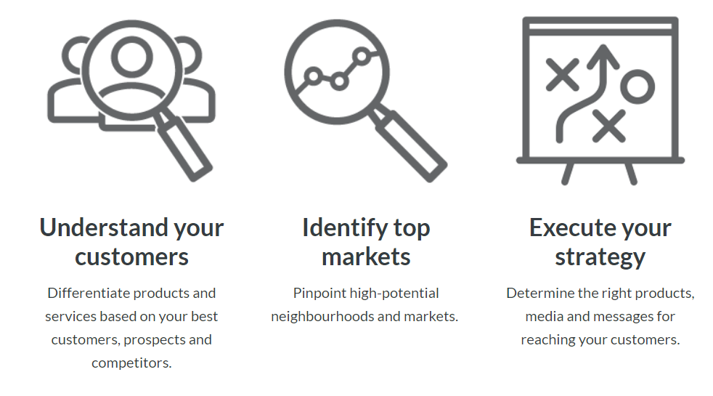

PRIZM marketing

**Targeting**

Once the overall market is divided into various segments then Hayai Desire needs to choose a target segment or few target segments.

**Conducting a Segment Attractiveness Analysis**

Under the Segment Attractiveness Analysis all the segments are evaluated based on the following criteria –

**Mode of competition and business model** – Sometimes the way competitors compete shape the whole landscape of an industry. For example, email can easily be paid product, but organizations chose to make it free products to increase customers base and lure in advertisers. So, if Hayai Desire is trying to enter a segment where revenue from other division is financing the core service then it has built a requisite business model where revenue is driven by an adjacent or related product and service.

**Customer Behaviour and Loyalty analysis** – How customers are behaving in each segment and are there opportunities of over lapping. Loyalty behaviour analysis is also a critical factor in analysing the conversion rate if Hayai Desire core strategy is based on attracting existing player’s customers.

**Maturity of the market** – For example, within the car industry the SUV category is more mature than electric vehicle market, so the margins can be very limited in the SUV category but the demand forecasting is easy. On the other hand, EV division can be higher margins because of lower competition bit the demand forecasting can be difficult process.

Profitability in various segments – Some segments often have higher margins compare to another.

**Differentiation & Positioning**

Differentiation process involves how Hayai Desire is differentiating its product and services in the market place compare to its competitors. Positioning is the position of the brand or Hayai Desire products in mind of target customers based on distinctive features, qualities and functions.

**The differentiation and positioning task at Hayai Desire**

Identify competitive advantage or unique value proposition on which position the brand in the mind of the customers.

Choose competitive advantages that are most compatible with Hayai Desire marketing strategy. Marketing team at Hayai Desire can make perceptual maps to better understand competitive positioning of various brands in the market place.

Finally Positioning the brand as a deliverer of superior value to the target segment and effectively communicating that position to consumer using marketing and promotion.

## Step 3 – Making a Marketing Plan

1. **Objective of the marketing plan**: There are various objectives for which Hayai Desire marketing can make marketing plans – new product launch, repositioning of existing brand and targeting new customer segment, entering international markets.
2. **Marketing and financial goals and objectives**: The second step is to correctly assess how much financial resources will be required to execute the marketing plan. It involves resources spent from product development to building a communication strategy.
3. **Marketing mix**: Building a marketing mix based on the market plan objectives and limitations imposed upon it by the financial resources.
4. **Marketing budget**: Budget each prospective activity that will be under taken under marketing strategy.
5. **Monitoring and evaluating performance**: Carefully monitor each marketing activity and analysis the target performance with the actual performance. Which media platform is performing better compare to others. This will help in making changes and adaptation.

## Step 4 – Four Ps of Marketing

To design the best marketing strategy and mix, Hayai Desire should closely adopt the four Ps of marketing mix in accordance with trends and forces in Hayai Desire’s marketing environment.

**Product** – understand the deep-seated drivers of perceptions and behaviours of consumers and develop a product that appeal to those drivers.

**Place** – Evaluate the buying behaviour and distribution channel costs to make a channel decision.

**Promotion –** Engage with customers through use cases and benefits instead of functionalities and features. Communication should be focused on experience rather than product features.

**Price** – Price is often determined by marketing strategy, cost structure of the company, competitive positioning of firm, brand positioning and various other factors. If the business model ins hilt on conversion of existing customers, then Hayai Desire needs to arrive at a price through research at which present customers are willing to switch to a new brand.

## Step 5 – Post Purchase Services

**Sustaining Value**

Even through the number varies, the efforts taken to gain new customers are far more and costly than those to keep the present customers loyal. Post purchase services are critical to foster loyalty among the customers. Various ways in which Hayai Desire can improve the post purchase experience of the existing customers:

* Providing regular maintenance services and spare parts, if the customers need them.
* Providing installation and other related services.
* Building communities where customers can share experience and help other customers.
* Taking regular feedback from customers and asking them how certain features can be enhanced.
* Providing product care tips.
* Post purchase services are critical not only to foster loyalty among the customers but also to get continuous feedback and improve the products.

# SWOT Analysis

The four key elements of SWOT analysis are: Strengths, Weaknesses, Opportunities & Threats. Hayai Desire can use strengths to crate niche positioning in the market, can strive to reduce & remove weaknesses so that it can better compete with competitors, look out to leverage opportunities provided by industry structure, regulations and other development in external environment, and finally make provisions and develop strategies to mitigate threats that can undermine the business model of Hayai Desire.

## Strengths – Hayai Desire

Strengths are the Hayai Desire capabilities and resources that it can leverage to build a sustainable competitive advantage in the marketplace. Strengths come from positive aspects of five key resources & capabilities – financial resources, human resources, physical resources such as land, building, activities & processes, and past experience and successes.

**Strong relationship with existing suppliers** – As a new player in the industry, Hayai Desire should make strong relationship with its suppliers and other members of the supply chain. “Organization can increase products and services by leveraging the skills of its suppliers and supply chain partners” (According to John Deighton, Leora Kornfeld).

**Strong Balance sheet and financial statement** of Hayai Desire can help it invest in new and diverse projects that can further diversify the revenue stream and increase return on sales and other metrics.

**Superior product and services quality** can help Hayai Desire to further increase its market share as the current customer can be extremely loyal to it, there is evidences that with high quality of products and services, Hayai Desire can compete with other global players in the international market.

**Partnership and Expansion** – Hayai Desire can partner with a bunch of grocery shops including Costco, Sam’s club, Total Wines etc. Below is a list of retailer partnerships (CB Insights, 2018).

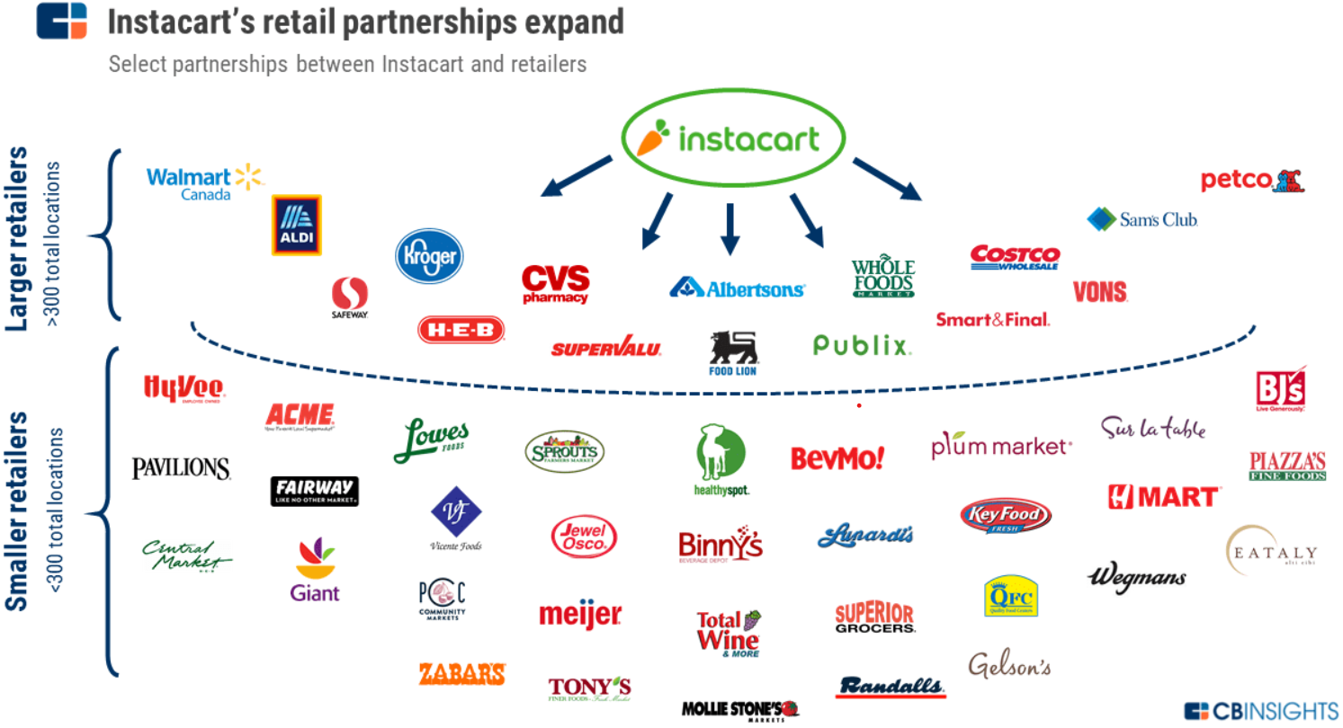

Source: CBINSIGHTS retail partnership

**Diverse Product portfolio** – Hayai Desire will not only offer grocery delivery but al so expand retail stores to include alcohol, where the shopper is requires to ID the customers for age limits. The drugstore and pet suppliers are also in high demand, among different generations, which shows a good range of diversity on products and customer base. Customers can also share their orders with family and friends.

**High Margins** – Hayai Desire can charge a premium compare to its competitors, this will provide Hayai Desire to not only thwart competitive pressures but also invest into research and development.

## Weaknesses – Hayai Desire

Weaknesses are the areas, capabilities or skills in which Hayai Desire lacks. It, limits the ability of the firm to build a sustainable competitive advantage. Weaknesses come from lack or absence of five key resources & capabilities – activities & processes, human resources, physical resources such as land, building, past experience and successes and financial resources.

**Inventory management** – Hayai Desire is a new enter in the industry, thus is not efficiently managing the inventory and cash cycle, there is a huge scope of improvement in inventory management.

**Customer Dissatisfaction** – Even though demand for product have not gone down but there is a sense of dissatisfaction among customers of Hayai Desire. It can be reflected on the review on various online platform. Hayai Desire should focus on areas where it can improve customer purchase and post purchase experience.

**Lack of critical talent** – Hayai Desire is suffering from lack of critical talent especially in the field of technology & digital transformation, Hayai Desire is struggling to restructure processes in light of development in the field of Artificial intelligence (AI) and machine learning.

**Store Coupons/Rewards and additional pricing** – Hayai Desire doesn’t allow applying coupons on the ordering app. Even through there has been a significant increase in the coupon’s usage from mobile devices, there is high and growing demand for coupons.

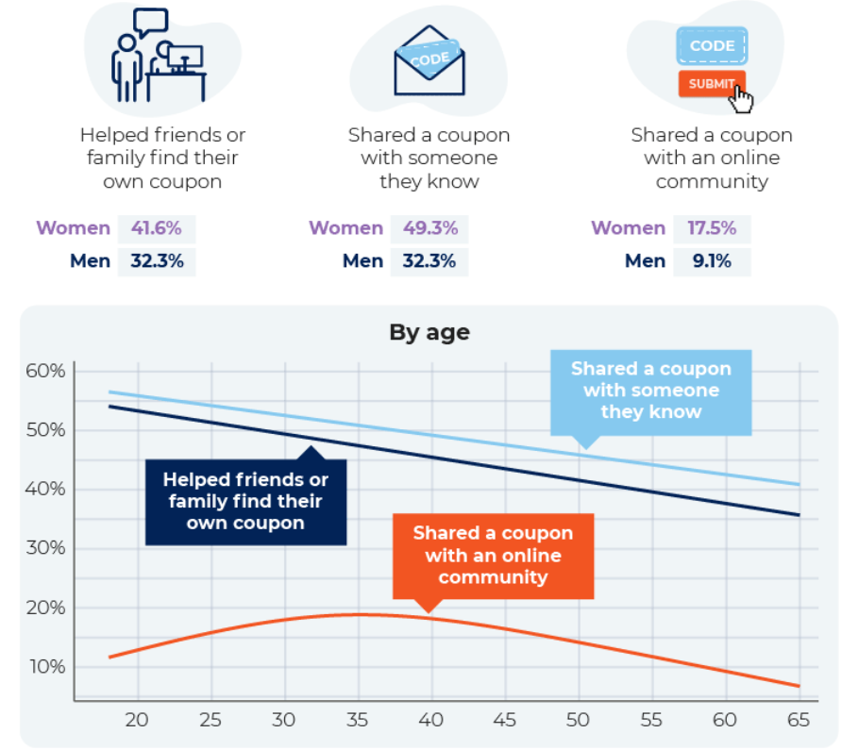

Source: shopper.com

**Mismatch on item delivered and customer choice** – As more runners/shoppers are being added to the Hayai Desire service, the quality of grocery and preference of customer goods can decline.

## Opportunities – Hayai Desire

Opportunities are Marco environment factors and developments that Hayai Desire can leverage either to consolidate existing market position or use them for further expansion. Opportunities can emerge from various factors such as: economic growth, changes in consumer preference, technological innovations, increase in consumer disposable income, and political developments & policy changes.

**Increase in consumer disposable income** – Hayai Desire can use the increasing disposable income to build a new business model where customers start paying progressively for using its products, Hayai Desire can use this trend to expand in adjacent areas.

**Changing technology landscape** – Machine learning and Artificial intelligence boom is transforming the technology landscape that Hayai Desire operates in, Hayai Desire can use these developments in improving efficiencies, lowering costs, and transforming processes.

**E-commerce and social media-oriented business model** – E-commerce business model can help Hayai Desire to tie up with local suppliers and logistics provider in international market. Social media growth can help Hayai Desire to reduce cost of entering new market and reaching to customers at a significantly lower marketing budget.

**Development in Artificial intelligence** – Hayai Desire can use development in Artificial intelligence to better predict consumer demand, cater to niche segments and make better recommendation engines.

**Growing market size and evolving preference of consumers** – Over the last decade and half the market size has grown at brisk pace. The influx of new customers has also led to evolution of consumers preference and tastes. Hayai Desire should diversify using different brands and then by adding features based on customer preferences.

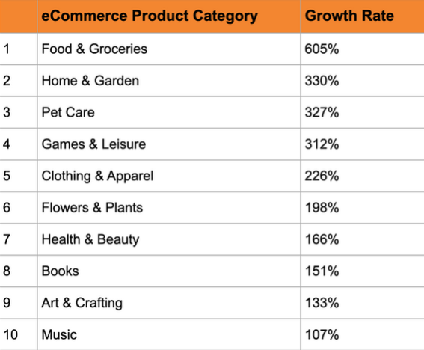

Source: Wix.com-Growth rate

**Access to international Talent in global market** – Expansion into international market can help Hayai Desire to tap into international talent market, it can also help in brining the talent into domestic market and expanding into new areas.

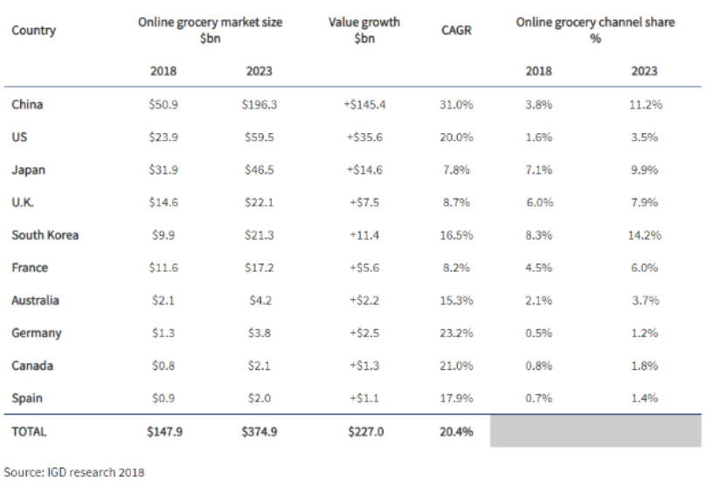

International growth Opportunities

## Threats – Hayai Desire

Threats are Marco environment factors and developments that can derail business model of Hayai Desire. Threats can emerge from various factors such as: technological innovations, political developments & policy changes, changes in consumer preference and economic growth.

**Threats of new entrants because of recusing costs and increasing efficiencies** – As Hayai Desire can leverage low cost of reaching customers using social media and e-commerce, so can the competitors both local and international competitors.

**Increasing costs components for working in developed market because of environment regulations** - Hayai Desire has to deal with this cost as government are trying to levy higher environment taxes to promote cleaner options, for Hayai Desire it may result into higher logistics costs and higher packaging costs.

**Government regulations** – Hayai Desire should keep a close eye on the fast-changing government regulations under the growing pressure from protest groups and non-government organization especially regarding to environment and labour safety aspects.

**Well established competitors** – Currently every retail store has started their own delivery models such as Amazon buying wholefoods and utilizing Amazon fresh, Walmart, or Target buying ship. These companies not only have a strong customer base, but they are also backed by strong financials.

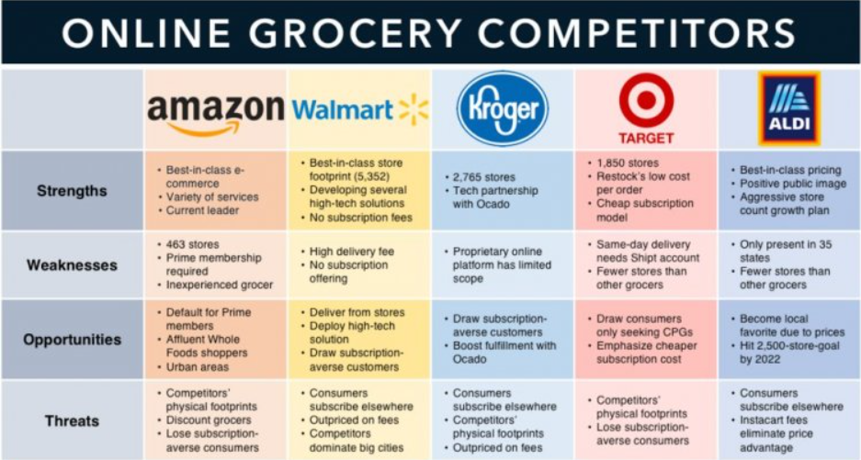

Competitive SWOT Analysis

**Recommendations**

SWOT analysis clarifies the current standing of Hayai Desire. Few necessary improvements are needed to be done to administer the lacking and reinforce its market position.

In short, Hayai Desire needs to strengthen its key areas, minimize its weakness, avail opportunities, and counteract threats for future progress.

1. Consolidate the market dominance by boosting its marketing efforts, promotional activities, and competitive advantages.
2. Increase its limited presence through opening physical stores outside the US. This will augment brand popularity and market reach.
3. Enhance its strategic entry in developing countries where many growth opportunities are available.
4. Improving the issues of cybercrime by upgrading technology measures.
5. Enhance network security system for the protection of consumer’s right.

# Core Competencies

The company’s main objective is to recognize that competition between companies is as much a race for the competition as it is for the marketplace situation and market authority. Consequently, the purpose for the organization of Hayai Desire is to focus on competencies that affect competitive advantage.

* Innovative infrastructure and logistics for fast delivery.
* Superior product and service quality.
* Robust domestic market that Hayai Desire operates in.

**Fast delivery**: With fast delivery, like same-day or next-day shipping, it removes one negative from online shopping. If the customers are satisfied with expedited shipping, they are likelier to continue to make purchase from Hayai Desire. For whatever reason the customer needs expedited delivery, having it can relieve great stress.

**Super product and service quality**: Product and services that meet or exceed customer expectations results in customer satisfaction. Quality is the expected product/services being realized. However, quality is a function of how the customer views the products/services that he or she receives.

**Robust domestic market**: The domestic market in which Hayai Desire operates is both a source of strength and roadblock to the growth and innovation of the company, Hayai Desire will grow in its domestic market without much innovation but will require further investment into research and development to enter international market.

# Bibliography

<https://corporatefinanceinstitute.com/resources/knowledge/strategy/pestel-analysis/>

<https://libguides.libraries.wsu.edu/c.php?g=294263&p=4358409#:~:text=A%20PESTEL%20analysis%20is%20a,organization%2C%20company%2C%20or%20industry.&text=A%20PESTEL%20analysis%20is%20used,used%20in%20a%20SWOT%20analysis>.

John Deighton, Leora Kornfeld (2018), "Instacart and the New Wave of Grocery Startups Harvard Business Review Case Study. Published by HBR Publications.

M. E. Porter, Competitive Strategy (New York: Free Press, 1980)

O. E. Williamson, Markets and Hierarchies (New York: Free Press, 1975)

Kotler & Armstrong (2017) "Principles of Marketing Management", Published by Pearson Publications.

W. Chan Kim and Renée Mauborgne (2017) Blue Ocean Shift: Beyond Competing - Proven Steps to Inspire Confidence and Seize New Growth, Sep 26, 2017

W. Chan Kim and Renée Mauborgne (2015) Blue Ocean Strategy, Expanded Edition: How to Create Uncontested Market Space and Make the Competition Irrelevant, Jan 20, 2015

<https://www.cbinsights.com/research/instacart-retailer-grocer-partners/>

<https://www.shopper.com/coupon-discount-statistics>

<https://www.wix.com/blog/ecommerce/2020/05/ecommerce-growth-report-during-covid-19>

<https://appscrip.com/blog/global-grocery-delivery-market-2019-projections-key-players/>